**Project Design Phase-II Technology Stack (Architecture & Stack)**

|  |  |
| --- | --- |
| Date | 05 Nov 2022 |
| Team ID | PNT2022TMID42769 |
| Project Name | Gas Leakage Monitoring & Alerting System |
| Maximum Marks | 4 Marks |

Technical Architecture:

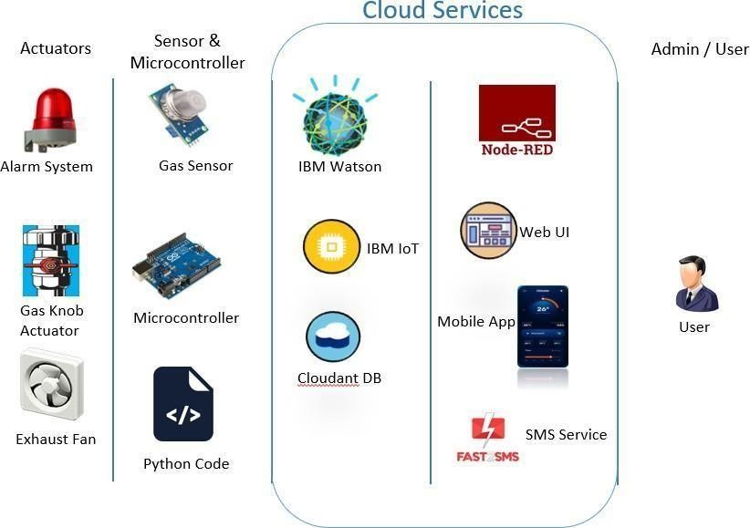

Table-1 : Components & Technologies:

|  |  |  |  |
| --- | --- | --- | --- |
| **S.No** | **Component** | **Description** | **Technology** |
| 1. | User Interface | How user interacts with application e.g. Web UI, Mobile App, Chatbot etc. | HTML, CSS, JavaScript / Angular Js / React Js etc. |
| 2. | Application Logic-1 | Logic for a process in the application | Java / Python |
| 3. | Application Logic-2 | Logic for a process in the application | IBM Watson STT service |
| 4. | Application Logic-3 | Logic for a process in the application | IBM Watson Assistant |
| 5. | Database | Data Type, Configurations etc. | MySQL, NoSQL, etc. |
| 6. | Cloud Database | Database Service on Cloud | IBM DB2, IBM Cloudant etc. |
| 7. | File Storage | File storage requirements | IBM Block Storage or Other Storage Service or Local Filesystem |
| 8. | External API-1 | Purpose of External API used in the application | IBM Watson IoT Platform, etc. |
| 9. | External API-2 | Purpose of External API used in the application | Fast SMS API, etc. |
| 10. | Infrastructure (Server / Cloud) | Application Deployment on Local System / Cloud Local Server Configuration:  Cloud Server Configuration : | Local, Cloud Foundry, Cloudant DB, etc. |

Table-2: Application Characteristics:

|  |  |  |  |
| --- | --- | --- | --- |
| **S.No** | **Characteristics** | **Description** | **Technology** |
| 1. | Open-Source Frameworks | List the open-source frameworks used | Python, Node RED Dashboard, MIT App  Inventor, Fast SMS |
| 2. | Security Implementations | List all the security / access controls implemented,  use of firewalls etc. | e.g. SHA-256, Encryptions, IAM Controls  etc. |
| 3. | Scalable Architecture | The user can also increase the range of the gas leakage monitoring system by increasing the number of sensors installed in the industry. Thus,  making the system highly scalable. |  |
| 4. | Availability | It allows realtime monitoring of gas leakage system  anywhere even in remote areas. |  |
| 5. | Performance | Fast SMS, Node RED provides realtime monitoring  of sensor status. |  |